Using Internet Explorer (OK)
- Resizing Content section:
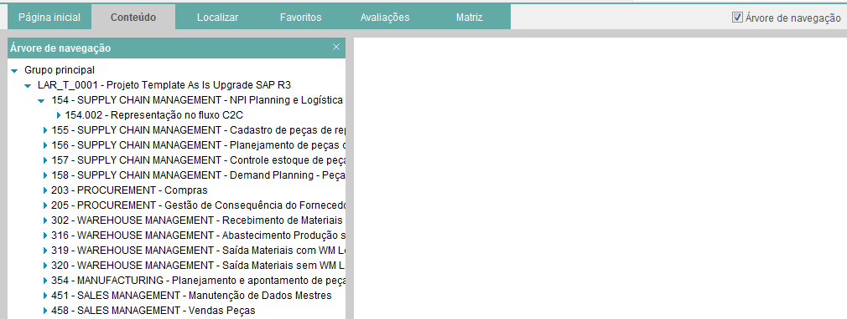
- Navigating to other tabs:
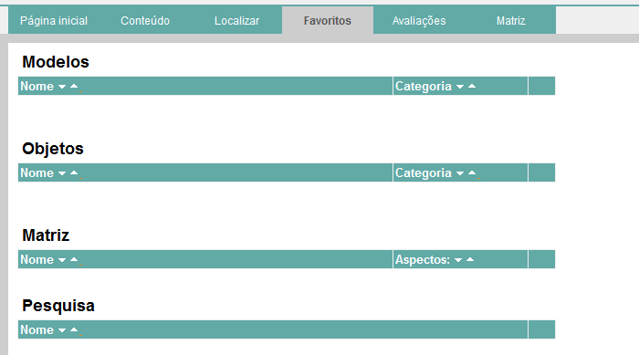
Using Chrome (Issue)
- Resizing Content section:
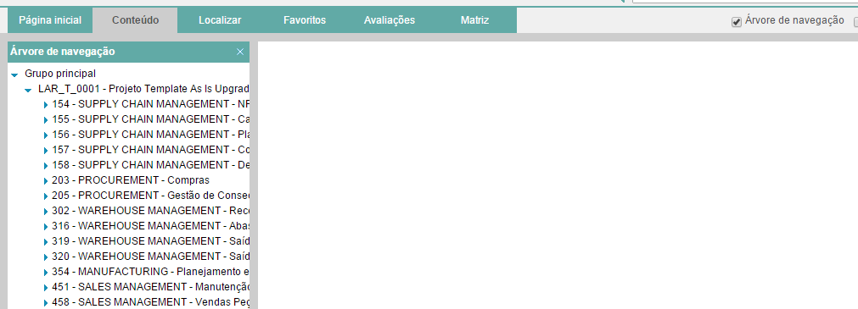
- Navigate to other tabs:
