Process Generator

Process Generator is an MS Excel based macro that can be used to complete the following activities when used in conjunction with ARIS:

- Create new objects
- Update attributes of objects already created in ARIS
- Create new models, including relationships

Create new objects

To create new objects, in the Explorer module, right click on the group and select Evaluate > Start macro.

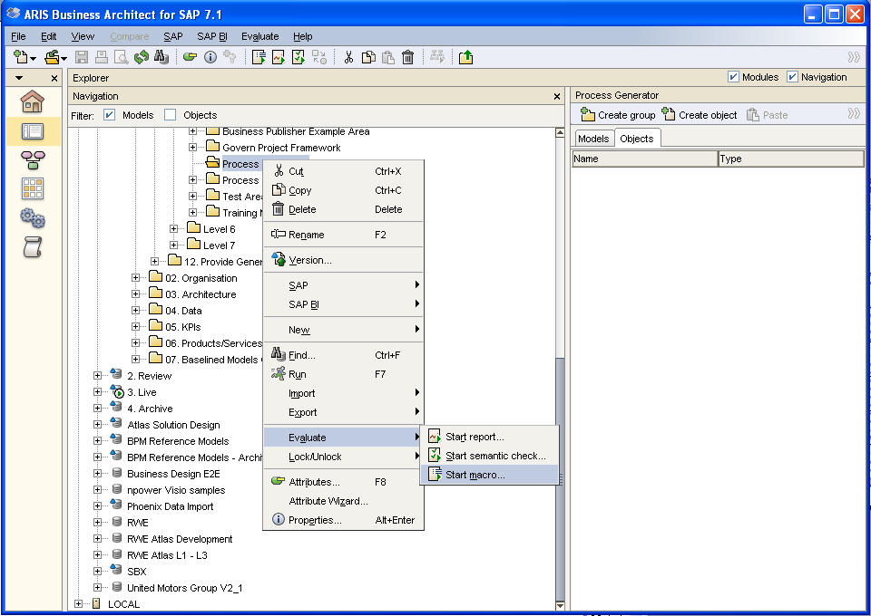

Select Open Excel table in Process Generator.

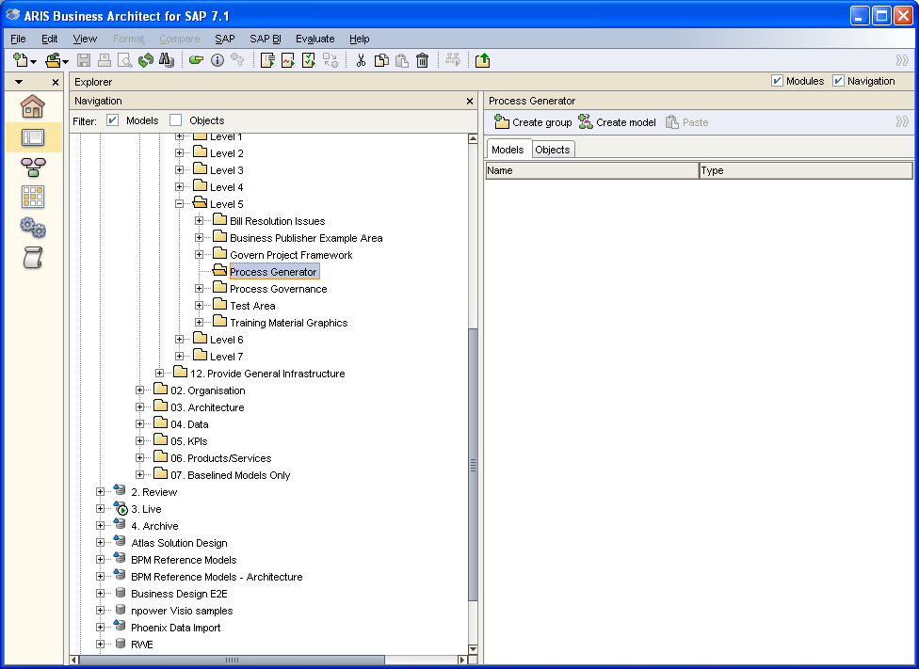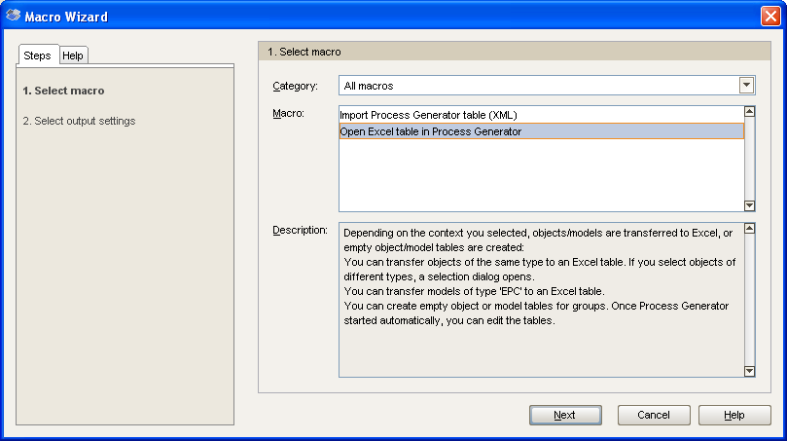

Leave default values, unless a different location for the output is required.

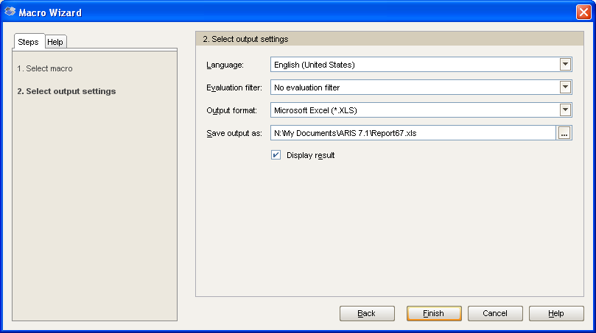
Select Create empty object table.

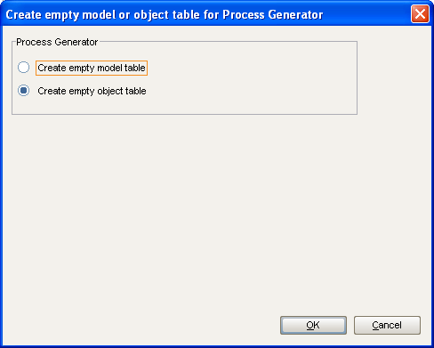

Click Enable Macros.

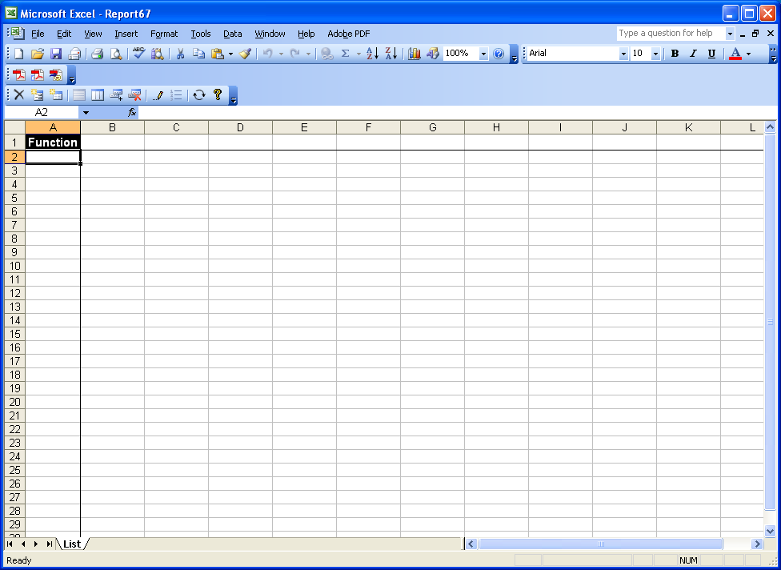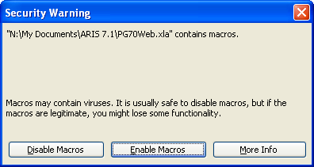
Add attributes against the objects by clicking the Edit columns icon on the Process Generator toolbar.

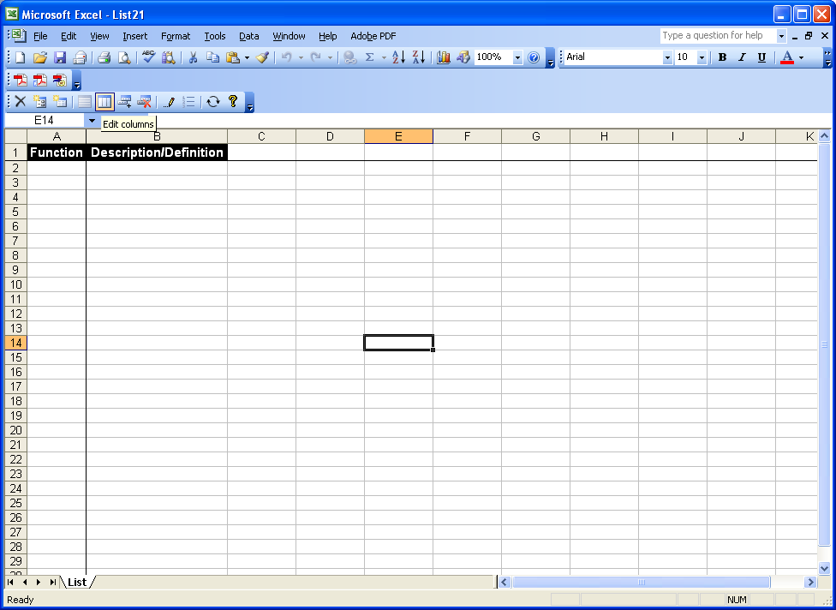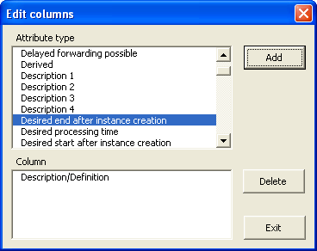

Complete object names and attributes.

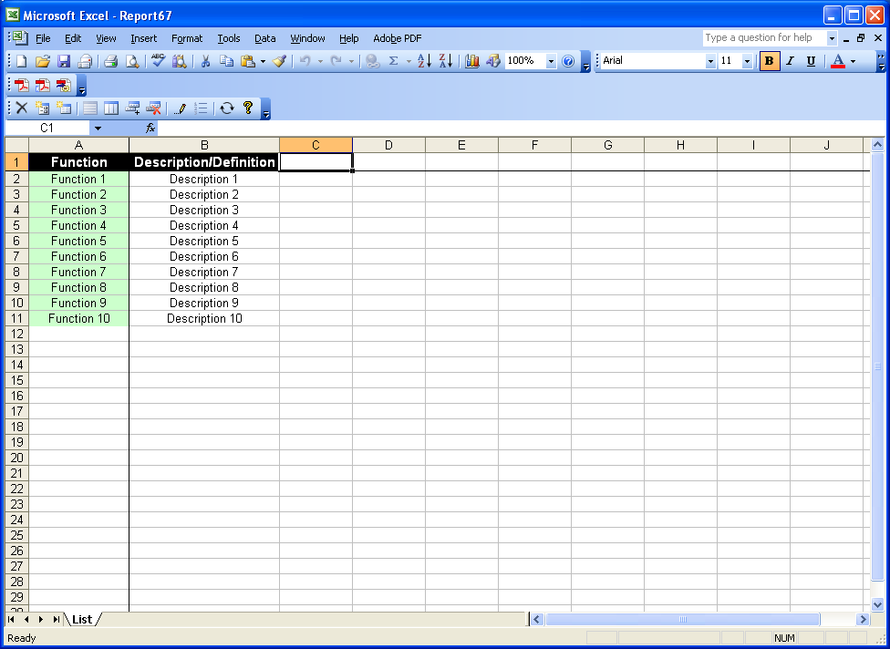
Once all objects and attributes have been captured, click the Synchronise button on the toolbar, and save the report to the required location.

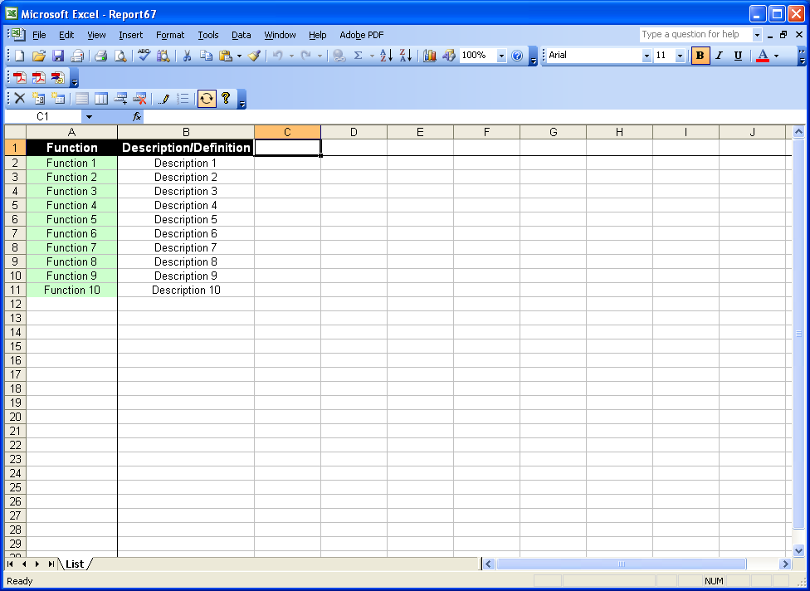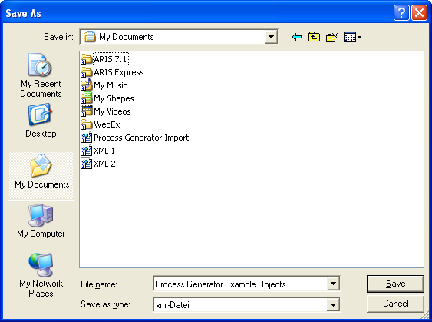

Synchronisation complete.

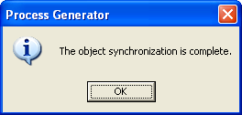
To import the new objects to ARIS, right click on the group where the objects are be to located and select Evaluate > Start macro.

Select Import Process Generator table (XML).

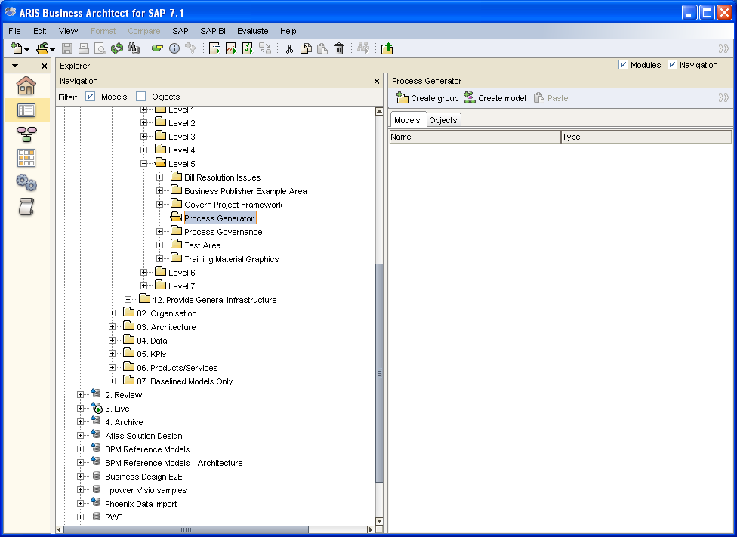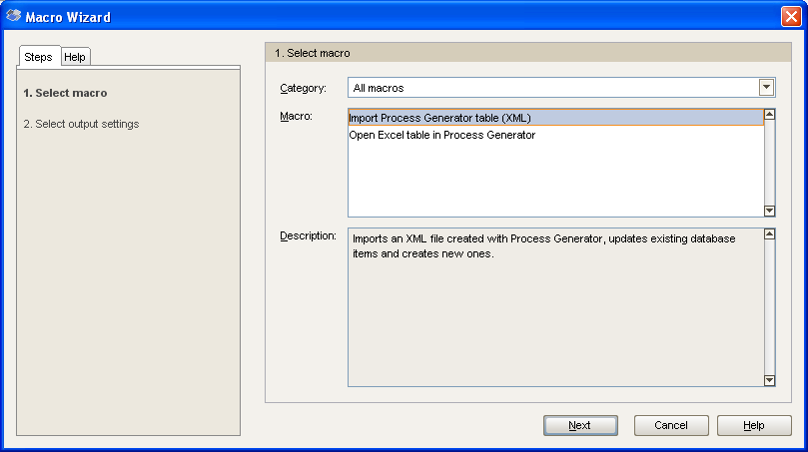
Leave default settings.

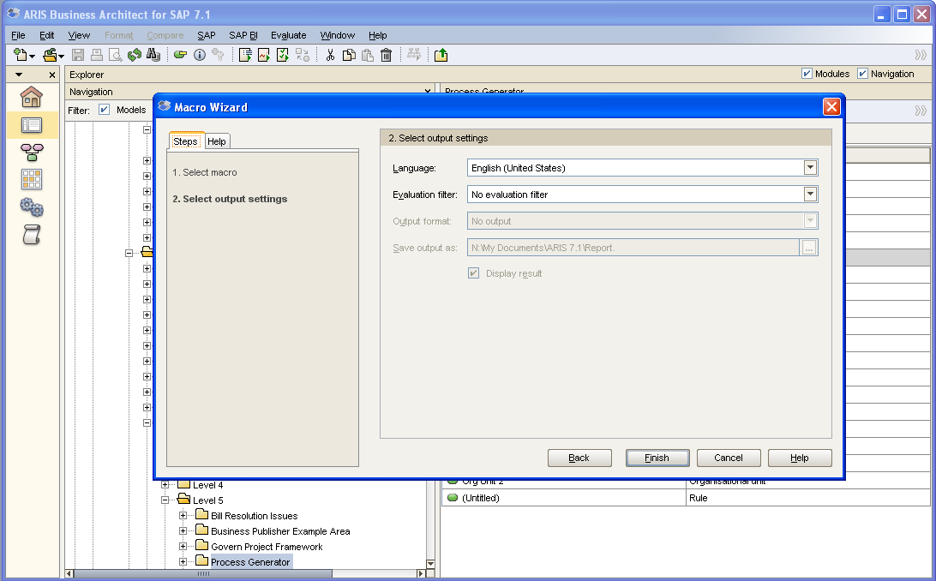

Select the synchronised file from the saved location.

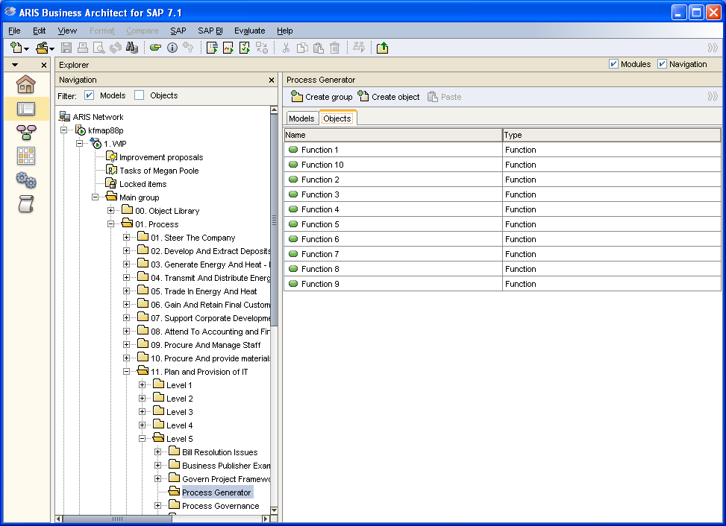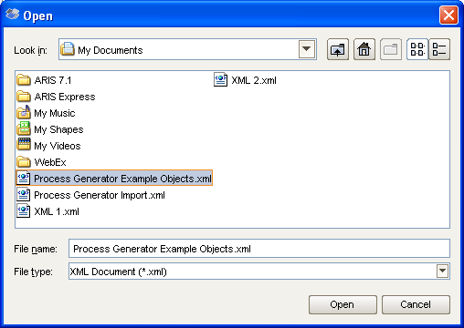
Click the Refresh button if the objects are not automatically displayed.

Double click on an object to display the populated attributes.

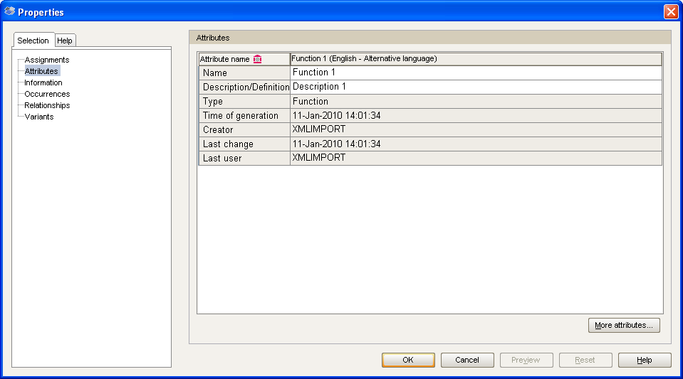

The objects are now available to be used in models.

Updating object attributes

In Explorer module select all of the objects to be updated, right click and select Evaluate > Start macro.

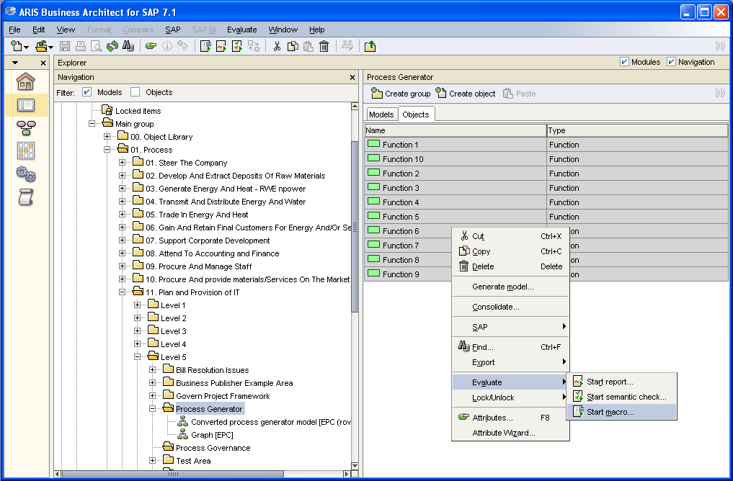

Select Open Excel table in Process Generator.

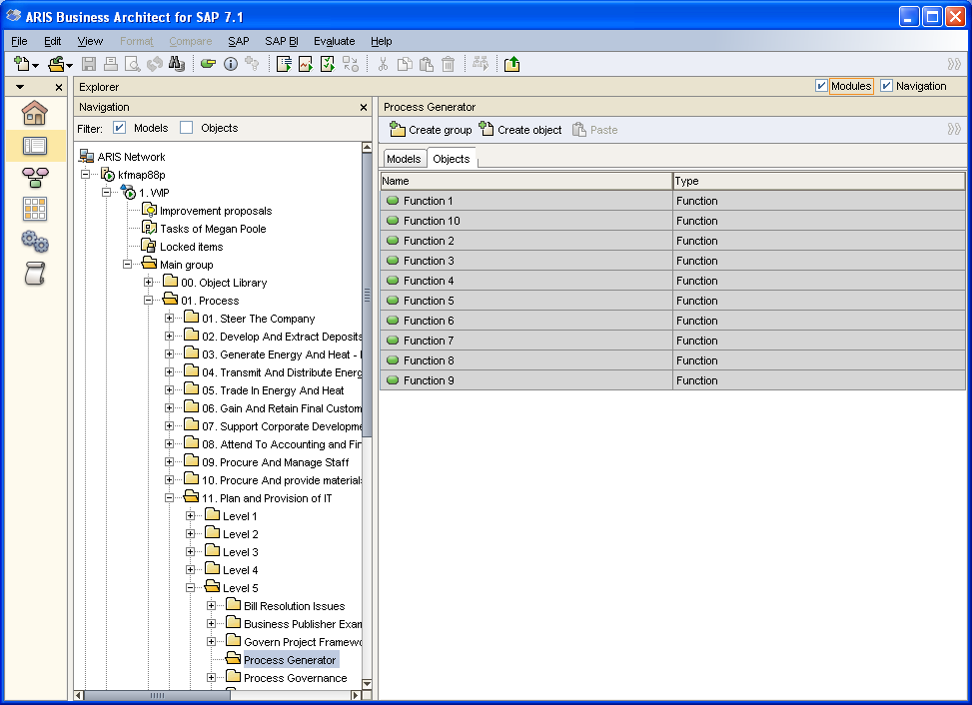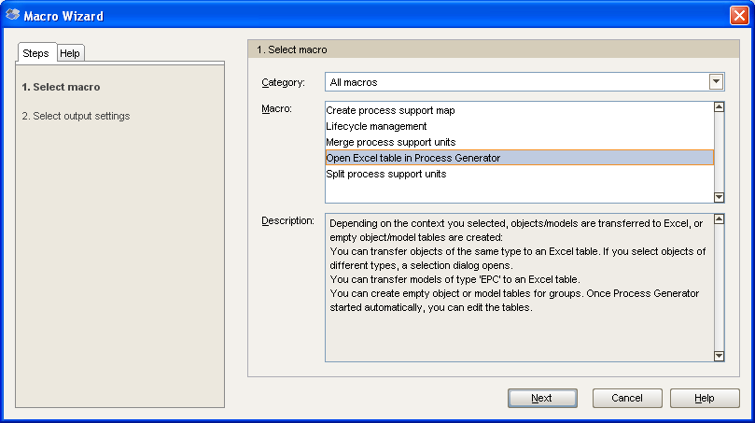

Leave the default setting unless another location is required for the output.

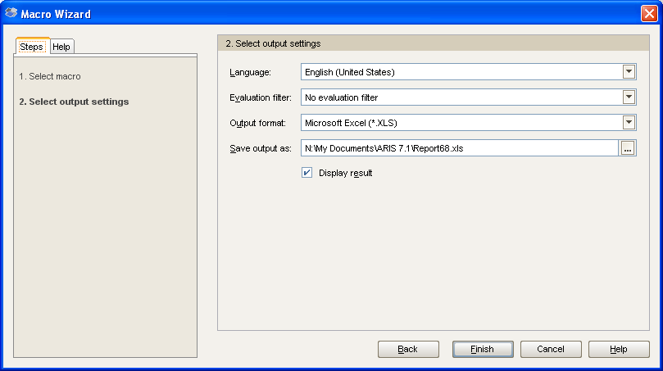

Select Enable Macros.

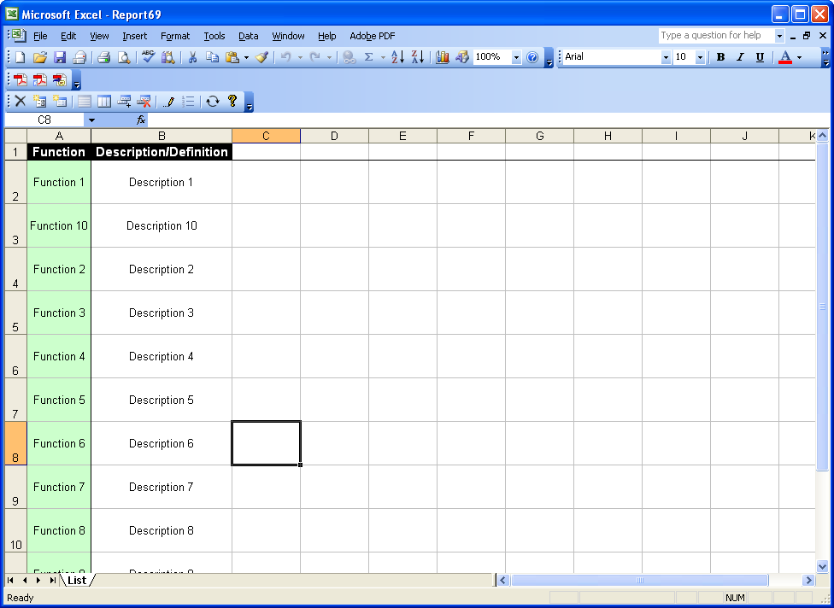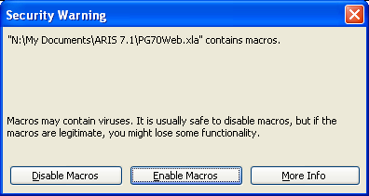

Update the existing objects and attributes as necessary. New objects can be added.

Click the Edit Columns button on the toolbar to add additional attributes.

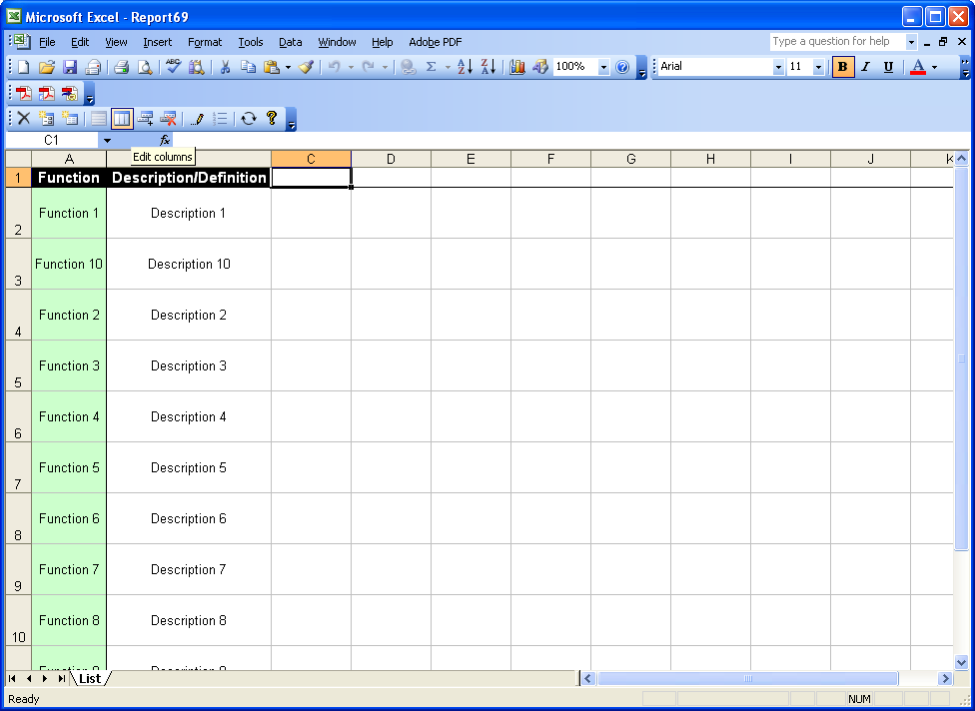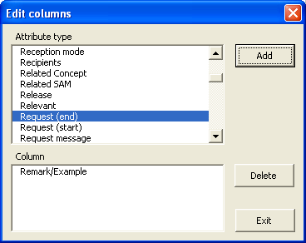

Complete any additional attributes.

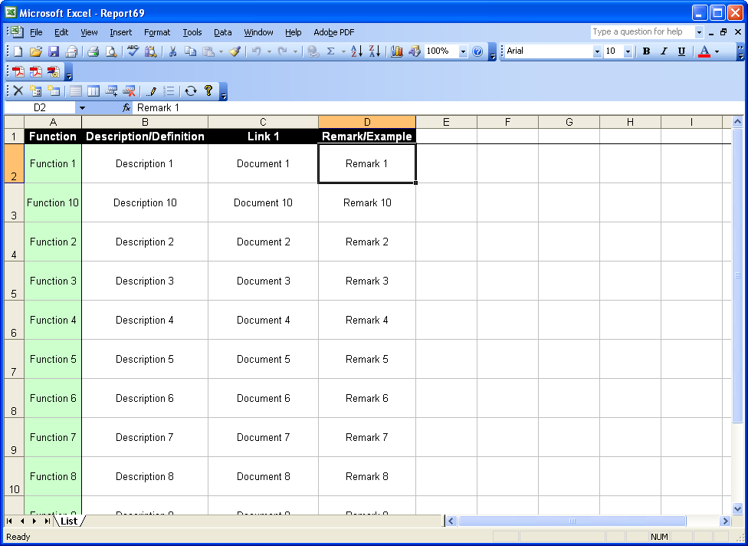

Select the Synchronise button on the toolbar and save the file.

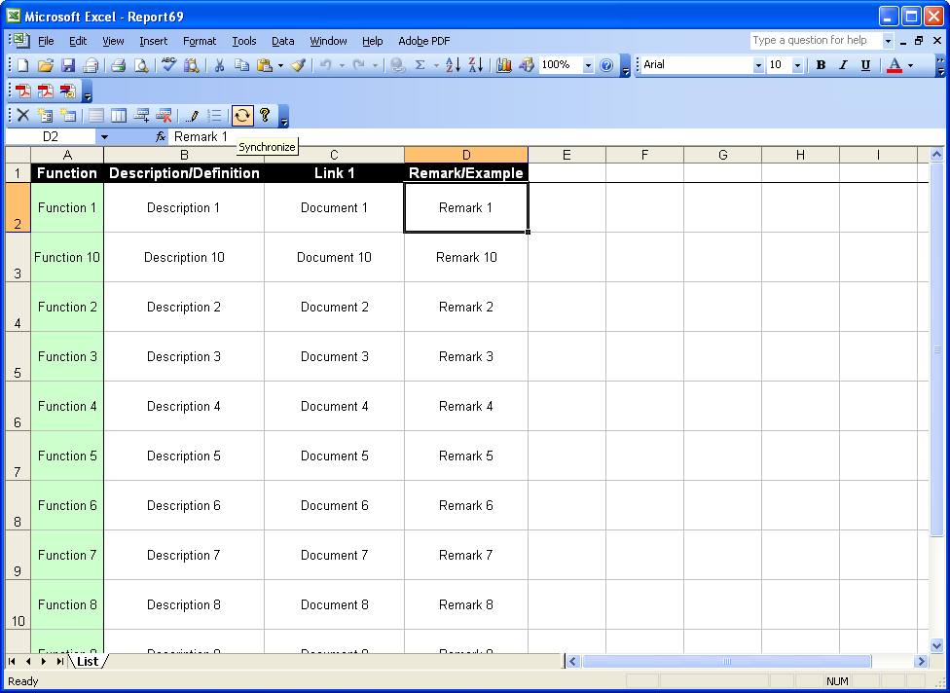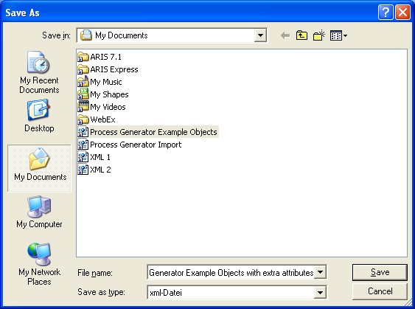

The synchronisation is complete.

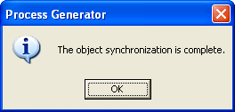

To import the new objects to ARIS, right click on the group where the objects are be to located and select Evaluate > Start macro.

Select Import Process Generator table (XML).

Leave default settings.

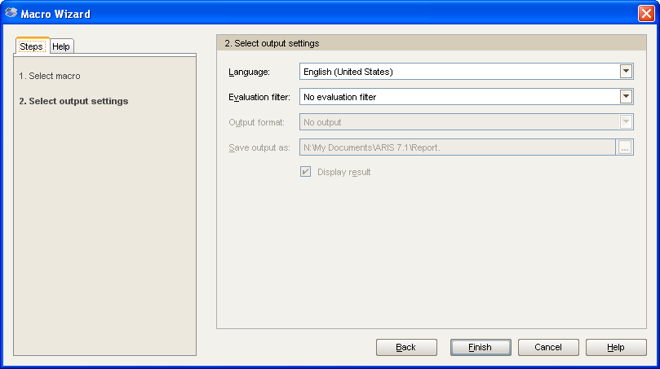

Select the synchronised file from the saved location.

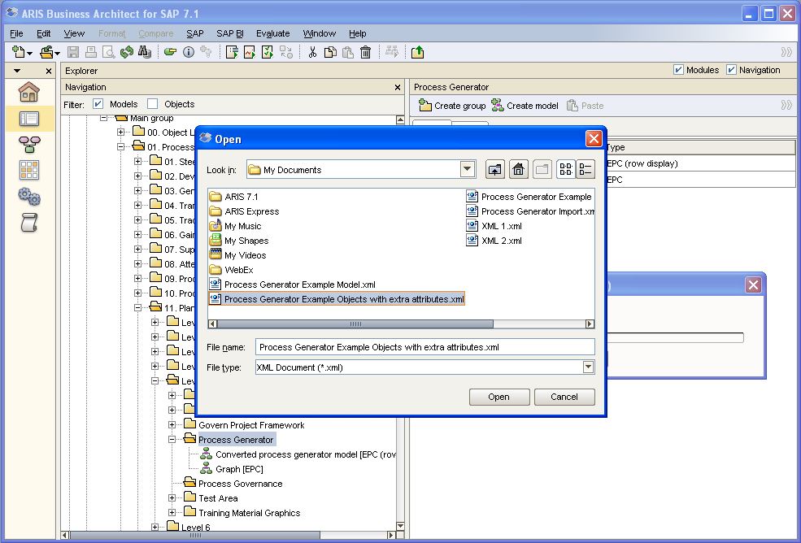

Click the Refresh button to refresh the objects.

Double click on an object to see the imported updates.

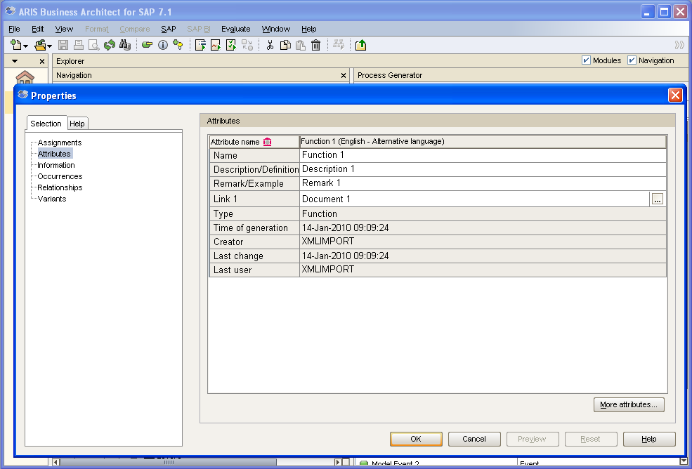

Creating models

To create a new model, in Explorer module right click on the group and select Evaluate > Start macro.

Select Open Excel table in Process Generator.

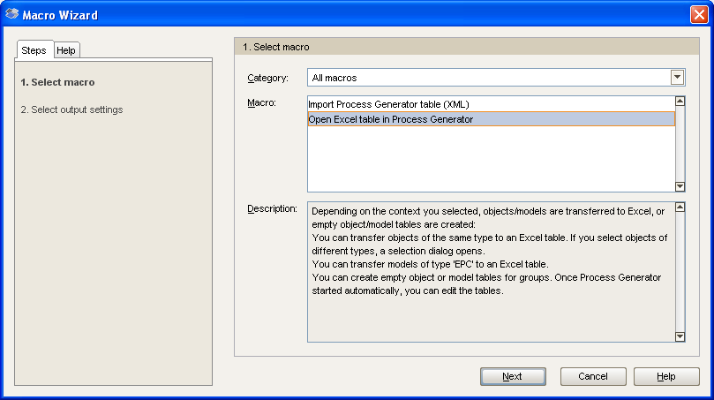
Leave defaults unless an alternative location is required for the output.

Select Create empty model table.

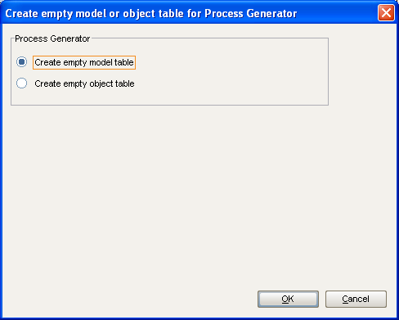
A blank model table will display.

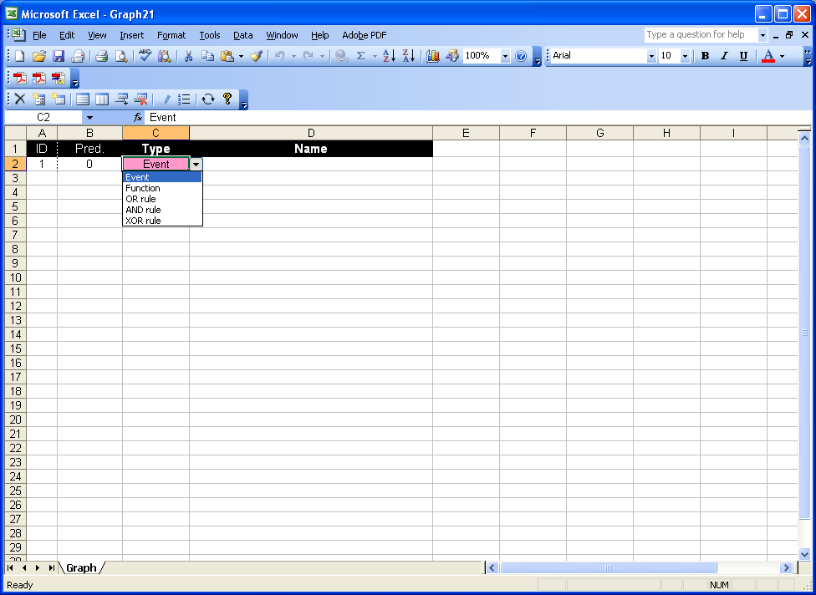

Update the table with object types and the associated names.

NOTE: Ensure that when using rules the Pred. (predecessor) column is correct. The table automatically assigns the previous object ID as the predecessor, which will always need to be updated when using rules. If the predecessor is not correct, the process will NOT import.

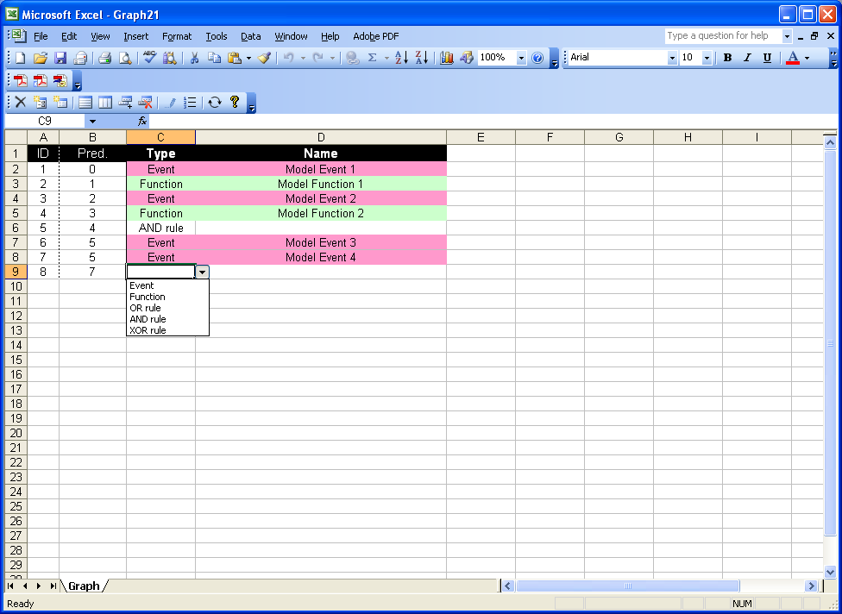
Add additional object types by clicking the Edit columns button on the toolbar.

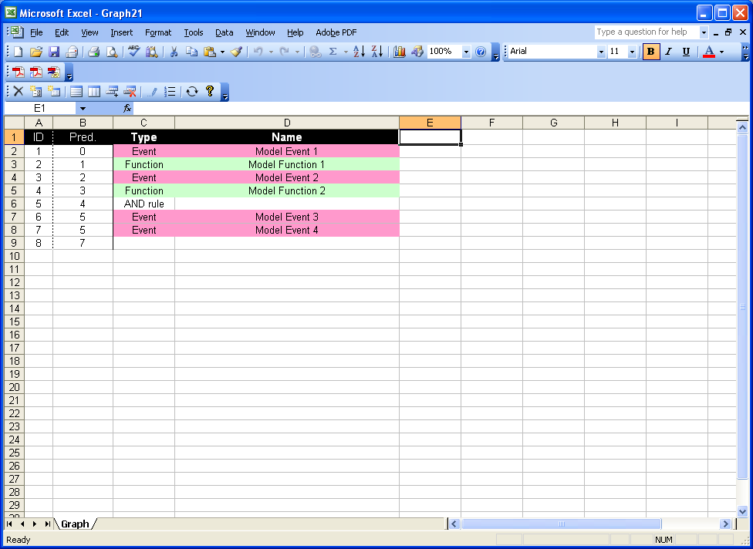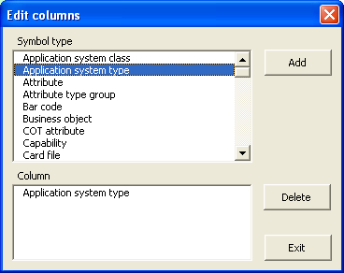

Add and complete additional objects as required.

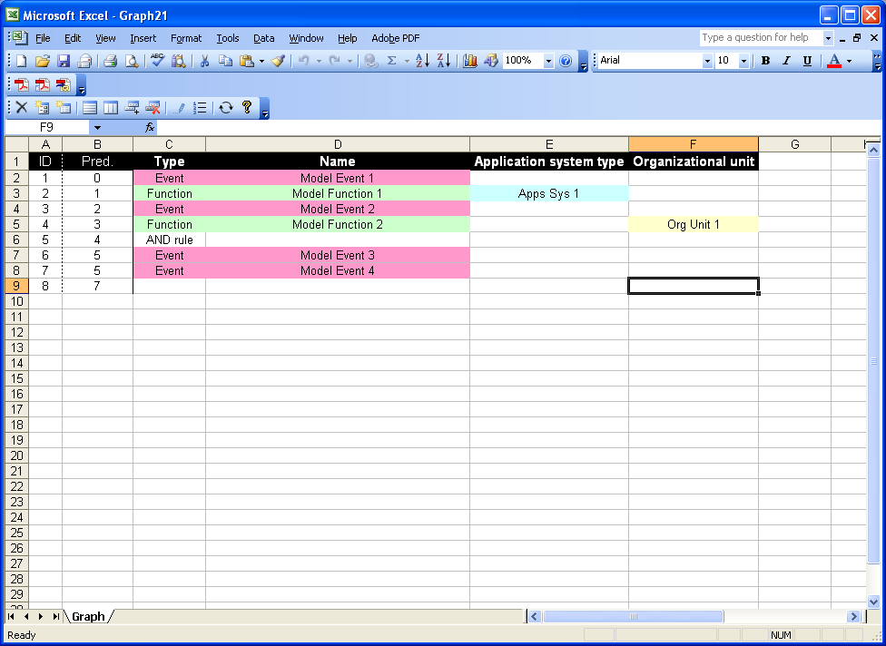
Click the Synchronise button on the toolbar to save the file.

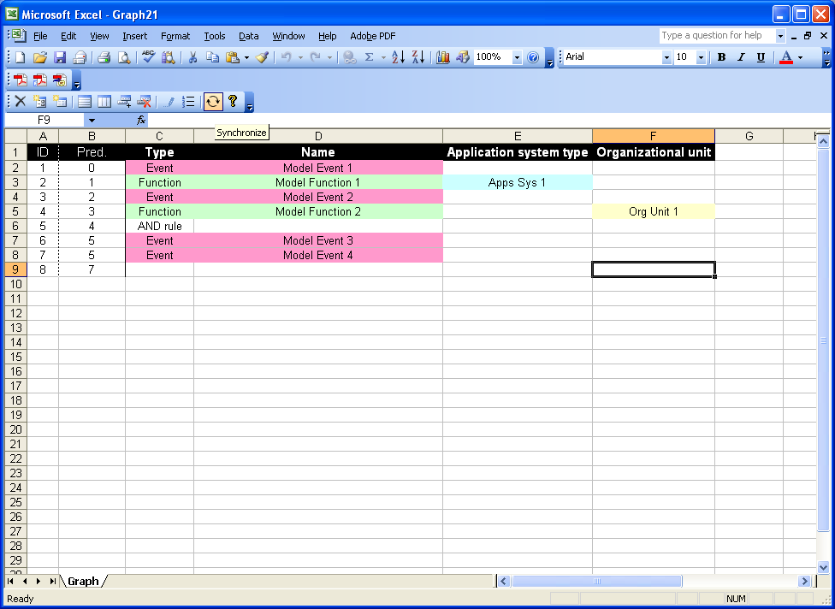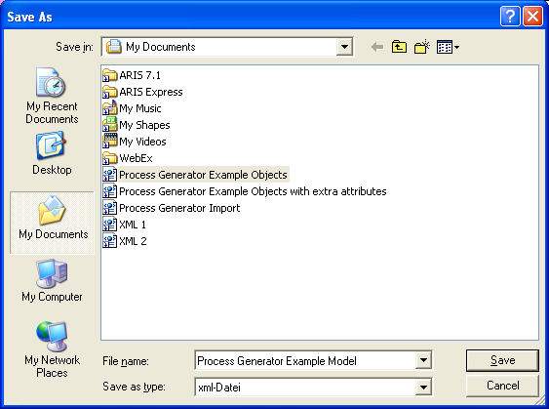

Ensure that the database is using the Process Generator filter. If not log in again using the filter.

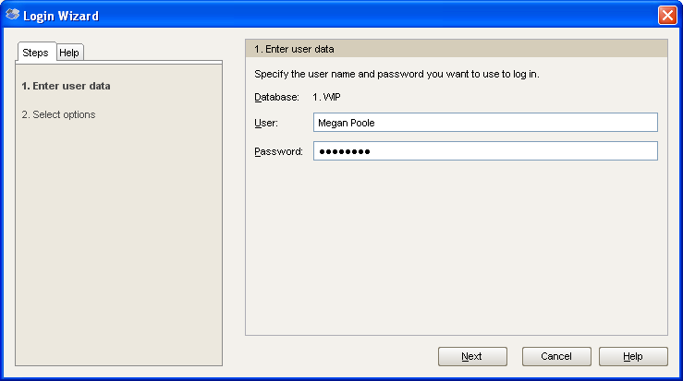
Select the Process Generator filter.

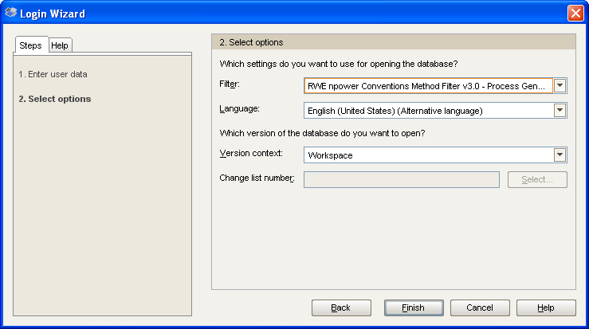

In ARIS right click on the group and select Evaluate > Start macro.

Select Import Process Generator (XML).

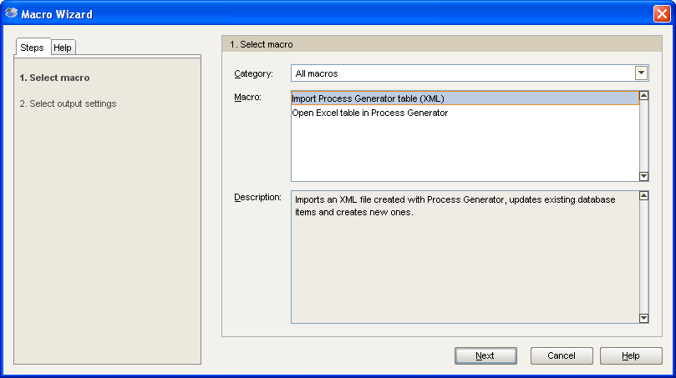

Leave the default values.

Select the saved model file.

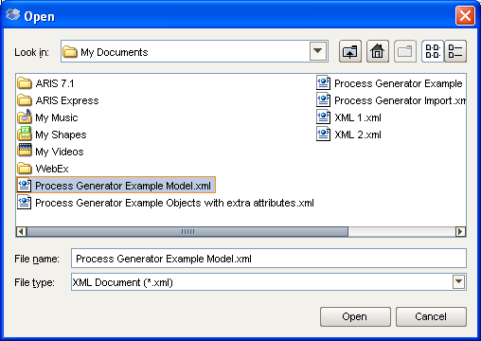

If the model does not automatically display the model and objects click the Refresh button on the toolbar.

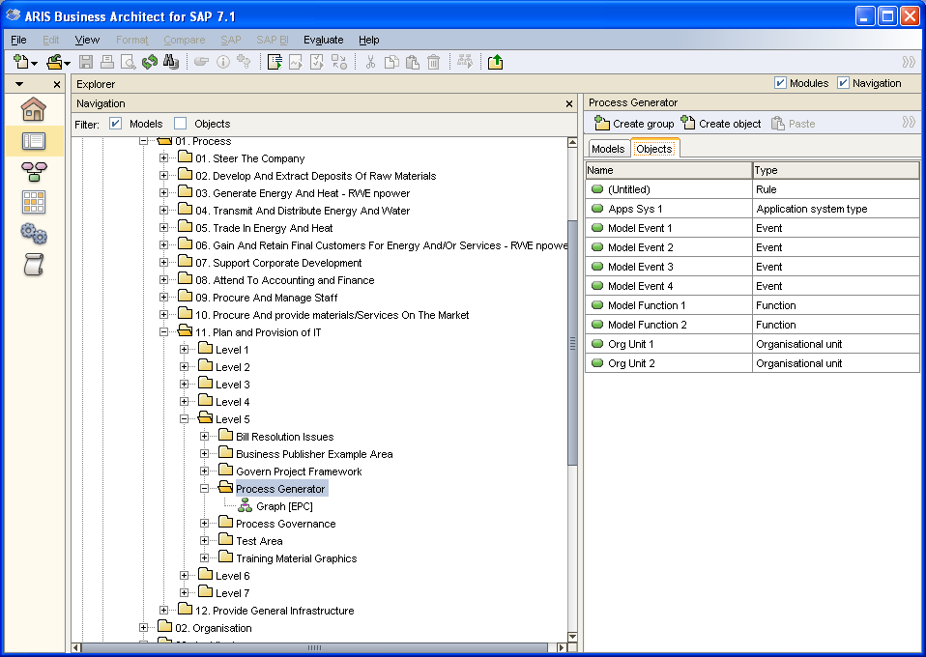
Double click the model to view it. Process Generator imports in EPC format rather than EPC Row Display and will need to be converted before being edited.

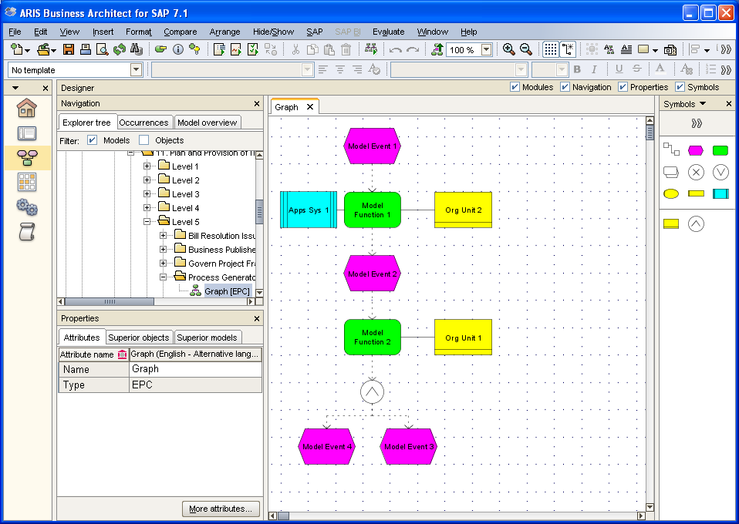

Right click on the model and select Generate model.

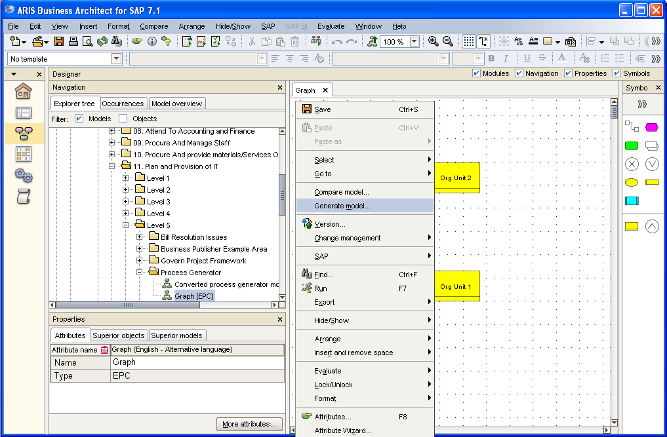
Select the objects to be included in the new model. This will most likely be all objects.

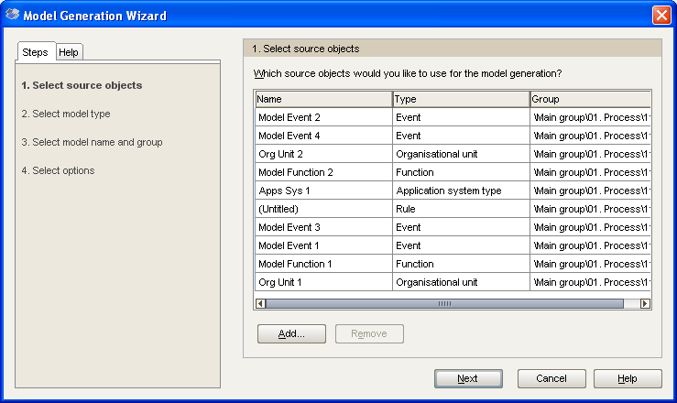

Select EPC (row display) model type.

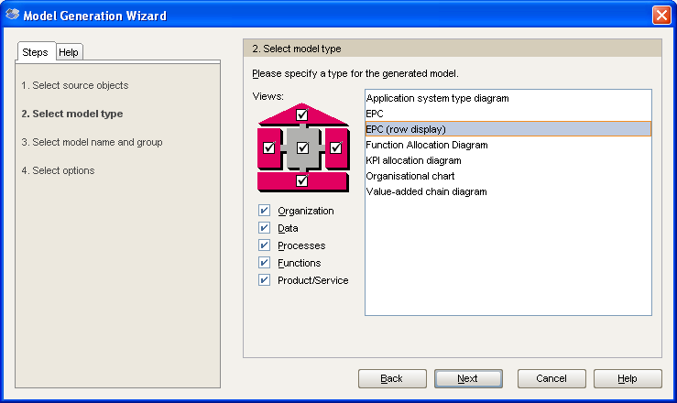
Select the group where the model will reside.

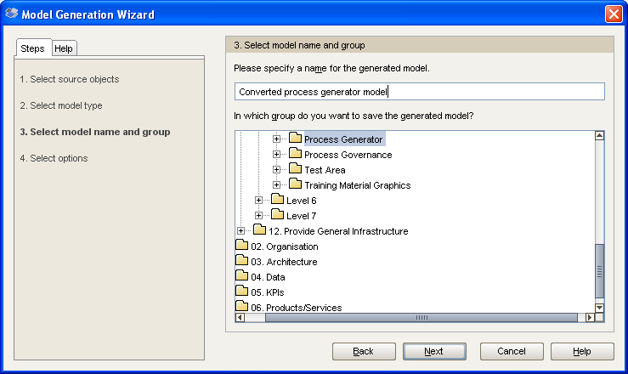

Select if relationships are required to be populated.

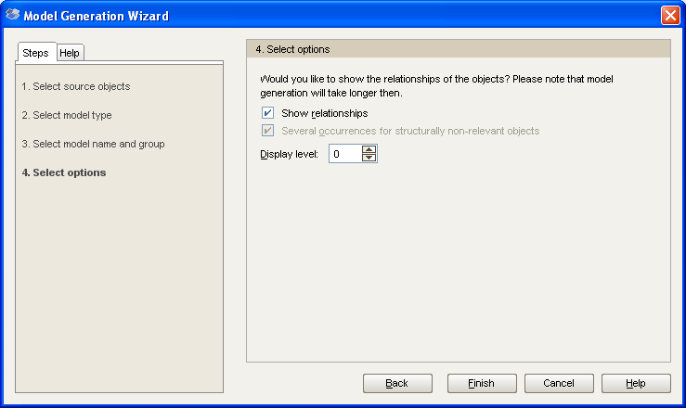

An EPC (row display) model is auto-generated.

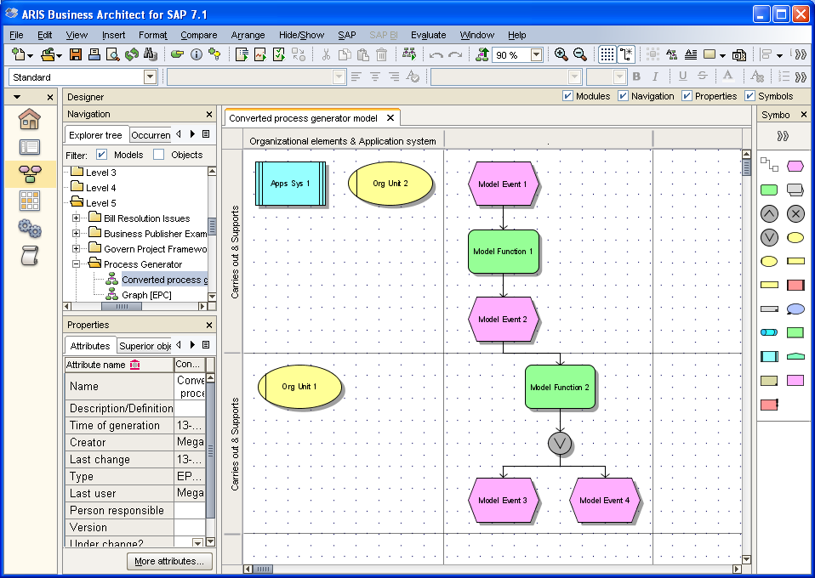

Reformat the model in line with the RWE npower conventions.

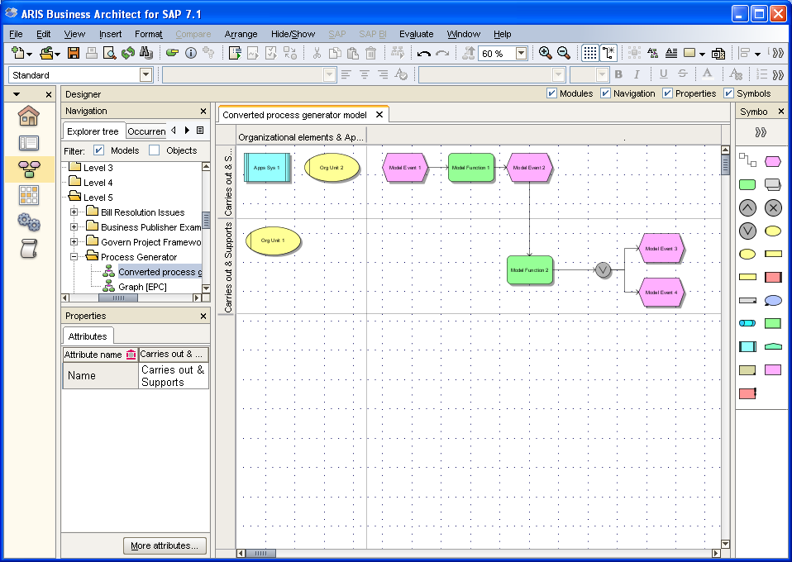

Edit the model in the RWE npower Conventions filter.

