Situation before synchronisation
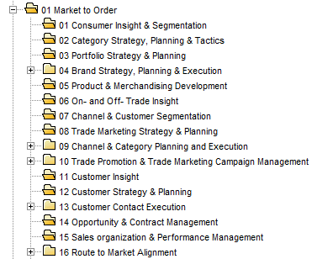
Folders 02, 03, 05, 06, 07, 08, 11, 12, 14 and 15 are empty.

Situation after synchronisation
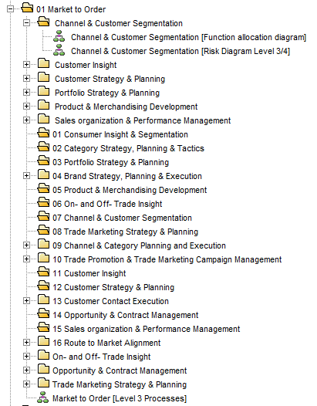
The new folders are the ones that are not numbered. They all have a FAD and a Risk Diagram Level 3/4 model.

