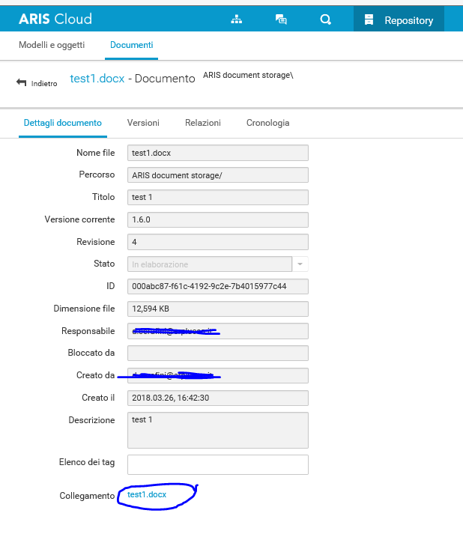
In the Document Aris Storage the link to the document test1 is related to the last version:
https://eu.ariscloud.com/documents/rest/links/dec809e6-5066-4ca8-809e-7288c923631a?tenantid=erplucca&revision=4

In the Aris Cloud Platform, the link to document related to the object, it’s not in the right version
test1:
https://eu.ariscloud.com/documents/rest/links/dec809e6-5066-4ca8-809e-7288c923631a?tenantid=erplucca&revision=3

