As is……
Currently when I want to view a model in ARIS, I go down the folder structure I created in Explorer. Clicking on the Process model open a new ARIS window, in this case Application Intake. In the Occurrences pane on the right, I see the models using in the diagram rather than the actual diagram.
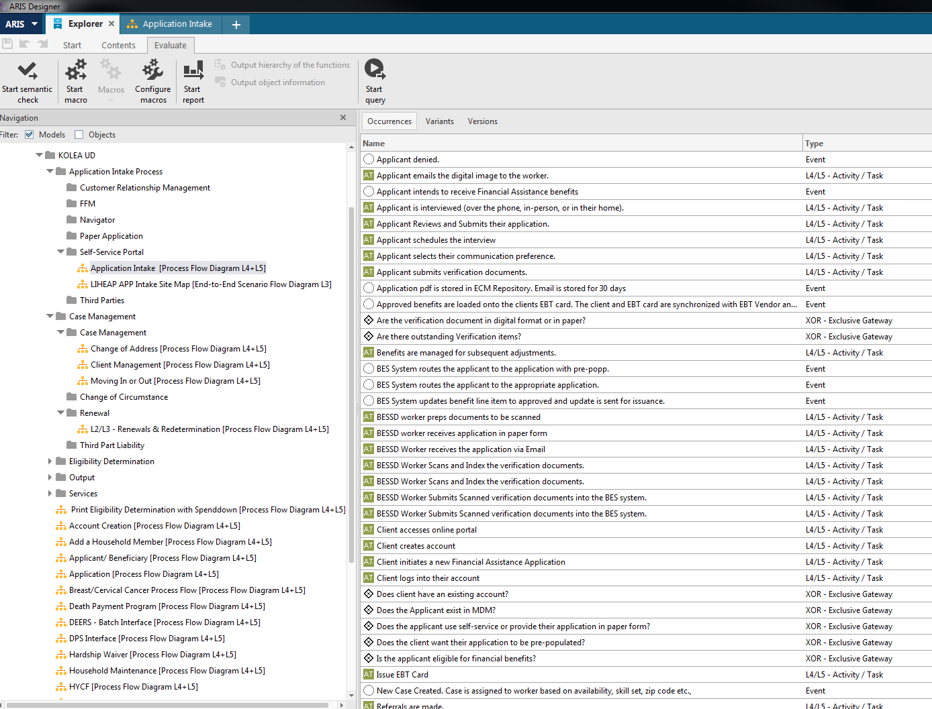

To be….
However, on our KPMG Enterprise Modeler, we see the process diagram right next to our folder structure. How can you get this view of the models in ARIS designer?
This view helps in viewing the hierarchy structure and the process model more easily.
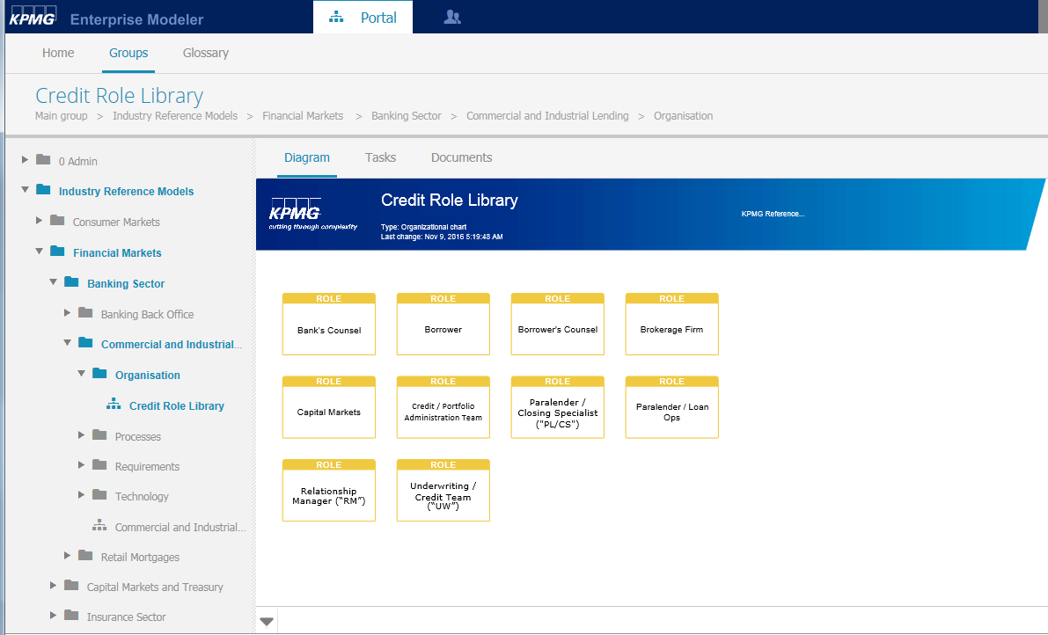

Please help!

Thanks,
Uma

