Error accessing ariscommunity.com at running ArisExpress for the first time
Environment:
Windows
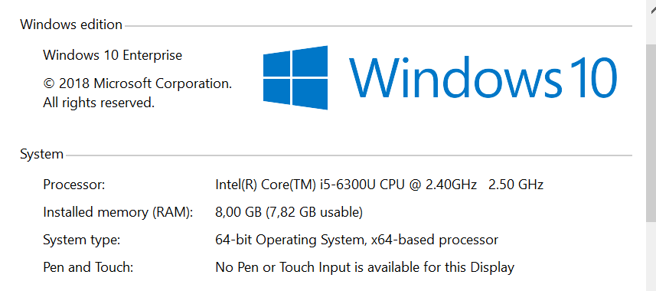
Java
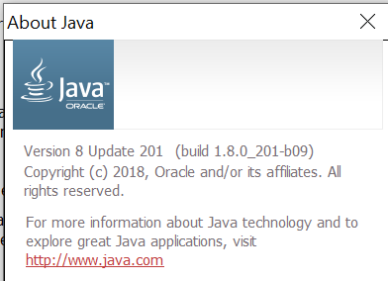

My workstation is located on a company network, using a proxy server.
STEPS FOLLOWED:
Installed ArisExpress 2.4d
Starting ArisExpress
At Activation Wizard, Step 3:
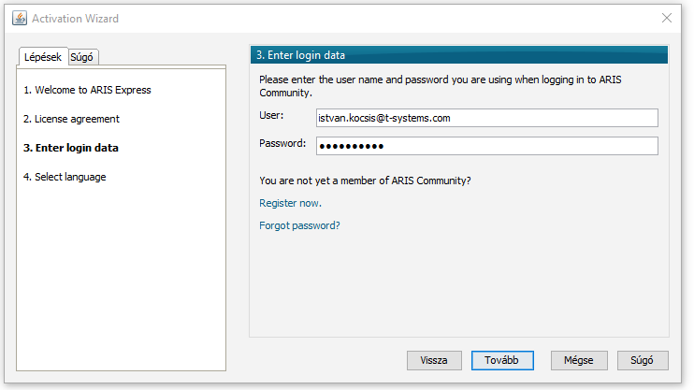
Entered credentials for an already existing registration.
(The login itself works)

I have tried the following settings in Java Contol Panel:
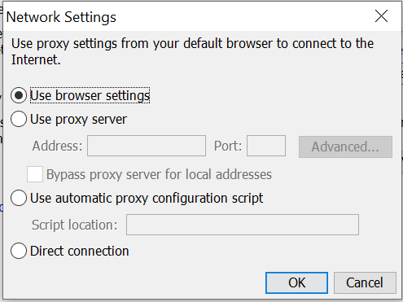
:
- Use Browser settings
- Use proxy server
At these trials I am getting the following error.
