I have performed the following steps:
- Create the Query in ARIS Architect
- Generate the Dashboard link
https://aris10.santalucia.net/octopus/mashzone?tenant=default&queryId=b67fb49d-64ba-4a76-8747-ecb9484ec64c&spreadsheetId=135a8bff-e9a9-42ad-842e-2e8d6fd8637e&tl=A1&br=B2&headerIncl=true&dbLang=es-ES&methLang=es-ES
- Create the data source in ARIS Aware, entering the parameters to test
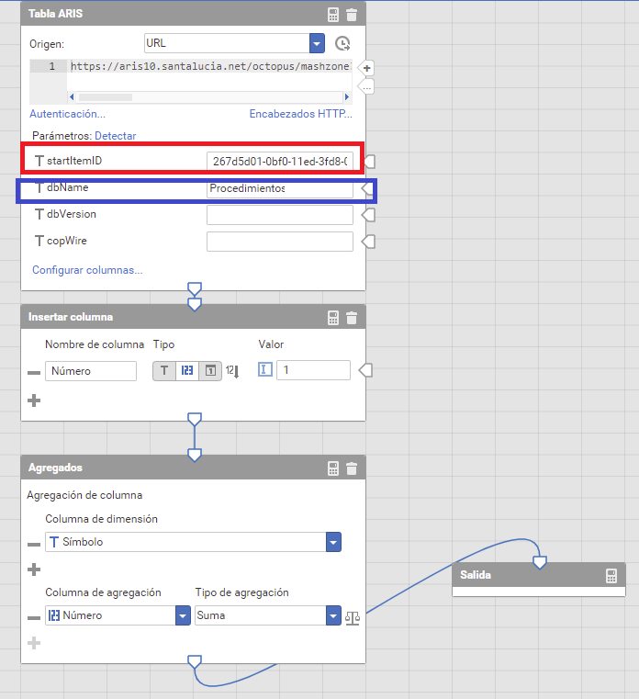

- Create the chart in Control Panel
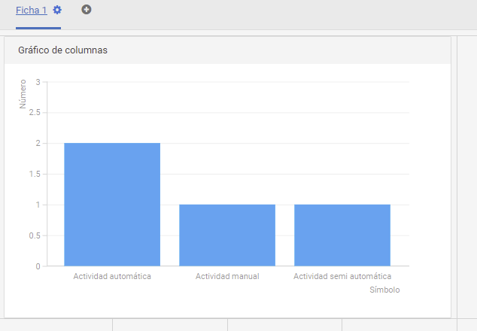
- Add Control Panel to the item process in ARIS Connect
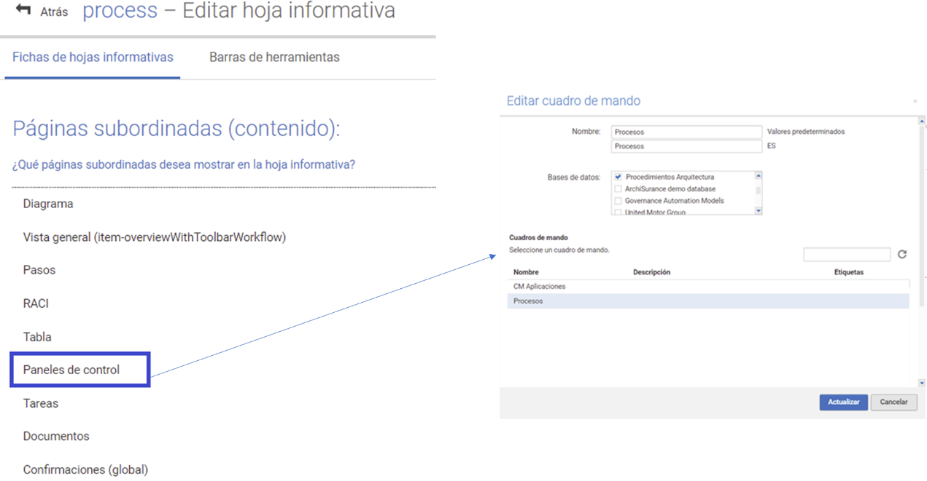

When I access ARIS Connect for different process-type diagrams I always visualize the same graph.
