Document was chosen from the local source. Still can’t proceed because I need to choose a target folder that when clicked shows ARIS Document storage:
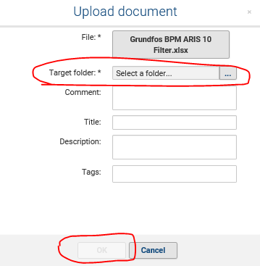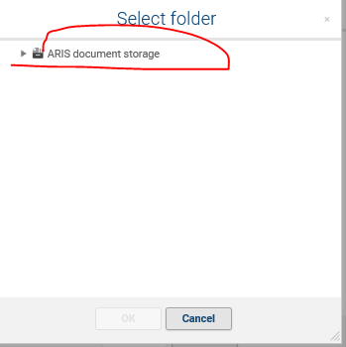

So when I chose a target folder from Doc Storage, it was only then that I can proceed with uploading document:
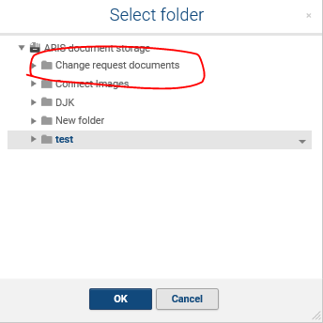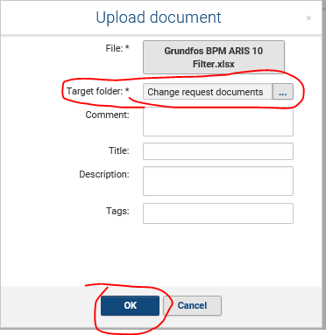

Can we skip this step and just proceed to importing from local source? Can we disable the Document storage?

