Spanish : text black
English : text red
Por favor su ayuda con los siguientes inconvenientes con la herramineta ARIS
Please help with the following problems with the ARIS tool

1.- Almomento de exportar la base de datos a ARIS PUBLISHER me solicita clave, anteriormente no me solicitaba nunguna clave y tampoco se ha modificado la clave de administrador.
1.- When I export the database to ARIS PUBLISHER, I am prompted for a password, I was not previously asked for a password and the administrator password was not modified.
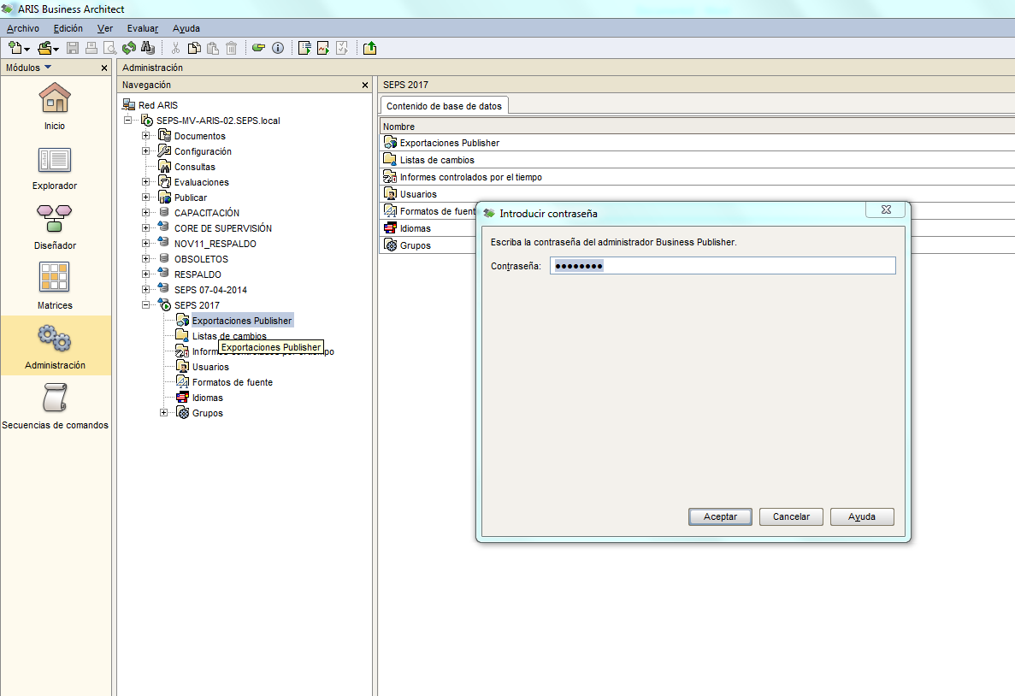

2.- Almomento de ingresar a configuración para crear plantillas o modificar el filtro metodológico me solicita clave, anteriormente no me solicitaba nunguna clave y tampoco se ha modificado la clave de administrador.
2.-When I enter the configuration to create templates or modify the methodological filter, it asks me for a password, I was not previously asked for a password and the administrator password was not modified

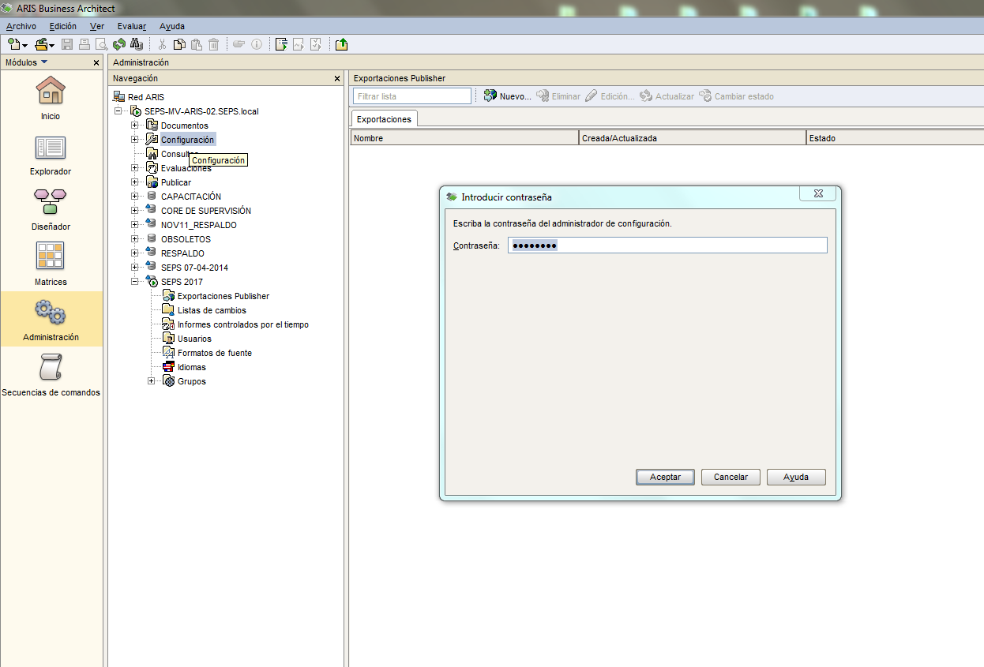

3.- Almomento de copiar la base de datos me solicita clave, anteriormente no me solicitaba nunguna clave y tampoco se ha modificado la clave de administrador.
3.-At the time of copying the database I requested a password, I was not previously asked for a password and the administrator password was not modified

