Hi Eva.
Thanks for your reply but I'm afraid I didn't explain well what I want to do.
What I need is to pass fields from the dashboard to a Datafeed, asociated to other widget, that have user variables as input.

I attach a document with more details.

This is an example:
The Data feed for Month has as Input user variable for the year: AnnFilter . I want to use the Year selected by the user in the dashboard to initialize this AnnFilter in the Data Feed.
In the old editor, once the user variable AnnFilter was defined in the data feed, it appeared in the Dashboard associated with the month, and you could use the filter option and initialize it with the year selected by the user.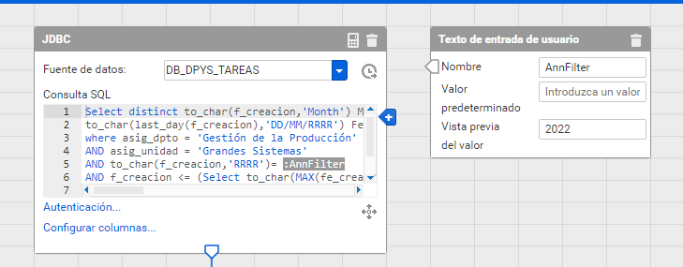
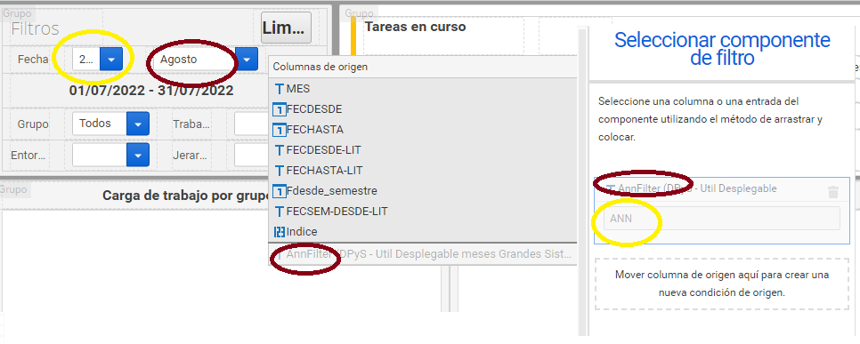

In the new editor, I use the same data source for the MES in the Dashboard. Once I assign it, AnnFilter appears associated in Stream1 but not in the user variable dropdown at the top.
It does not appear as a filter option neither, so when I automatically switch from the old dashboard editor to the new one it tells me that some settings could not be set.
